YouSaveIt WEBSITE
Interface Design Document


TEAM: EAGLE
Version: V.1.0

Revision History
Date | Version | Description | Custodian/Organization
29/09/2013 | 1.0 | Initial publication. | Trần Công Bình

Table of Contents
1. Introduction 2
1.1 Purpose 2
1.2 Scope 2
1.3 Reference 2
2. List of interface 3
3. Interface Specification 4
3.1 Change information interface 4
3.2 Send request interface 6
3.3 Accept/Reject request interface 8
3.4 Manage request interface 9
Appendix A: Approval 11

Introduction

Purpose
- This document helps to better understand the interface of the YouSaveIt Website, detailed specification components and function of the website.
- With this document, the development team can understand the structure and composition to create a consistent and complete system.

Scope
- Overview of the stages and modules of the software.
- Create complete interfaces, and descript them clearly.

Reference
- SRS document
- Architect Design Document
- Database Design Document

List of interface
No. | Interface code | Interface name | Detail
1 | ID07 | Change information interface | Form change user’s information
2 | ID08 | Send request interface | User send request
3 | ID09 | Accept/Reject request interface | User accept or reject request from another user
4 | ID10 | Manage request interface | User edit or delete request

Interface Specification

Change information interface
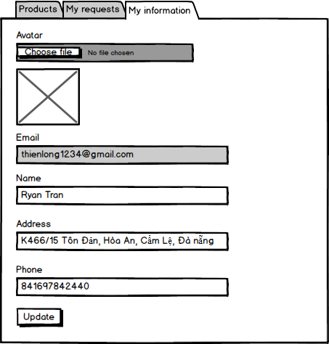
Figure1: Change information interface

Table 1: Detail description Change information interface
Change information Interface |  |  | Code: ID07
No. | Field Name | Type | Target | Comment
1 | My information | Tab selection | Text for guide
2 | Avatar | Label | Text for guide
3 | Choose file | Button | Choose file from computer for upload | Only 1 file from computer
4 | Email | Label | Text for guide
5 | Email | Textbox | Show email of user was registered before | Can’t not edit
6 | Name | Label | Text for guide
7 | Name | Textbox | User change their name on it
8 | Address | Label | Text for guide
9 | Address | Textbox | User change their address on it
10 | Phone | Label | Text for guide
11 | Phone | Textbox | User change their phone on it
12 | Update | Button | Check all field if valid the information will be change  If fail, display error

Send request interface

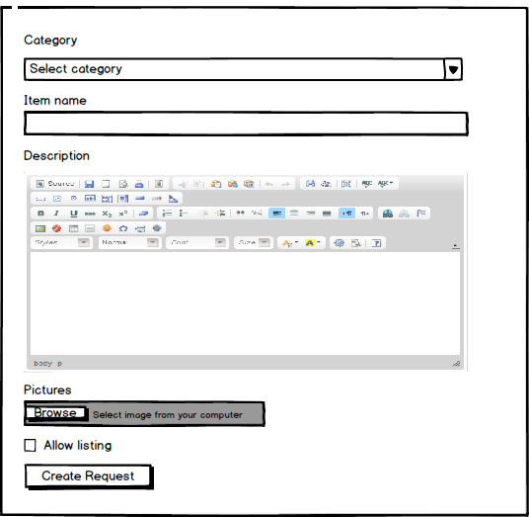
Figure 2: Send request interface

Table 2: Detail description send request interface
Send request interface |  |  |  | Code: ID08
No. | Field Name | Type | Null/ Not null | Target | Comment
1 | Category | Label |  | Text for guide | Color = black Font size = 16
2 | Category | Dropdown box | Not null | Display all category on database
3 | Item name | Label |  | Text for guide | Color = black Font size = 16
4 | Item name | Textbox | Not Null | User put item name of their topic
5 | Description | Label |  | Text for guide | Color = black Font size =16
6 | Description | Container | Not null | User put description of their topic | Use ckeditor to enhance text
7 | Thumbnail | Label |  | Text for guide | Color = black Font size = 16
8 | Thumbnail | Container | Not null | Upload image from user’s computer
9 | Allow listing | Checkbox |  | If checked it will display this topic in homepage
10 | Create request | Button |  | Check all field if valid then send request to the author of this topic

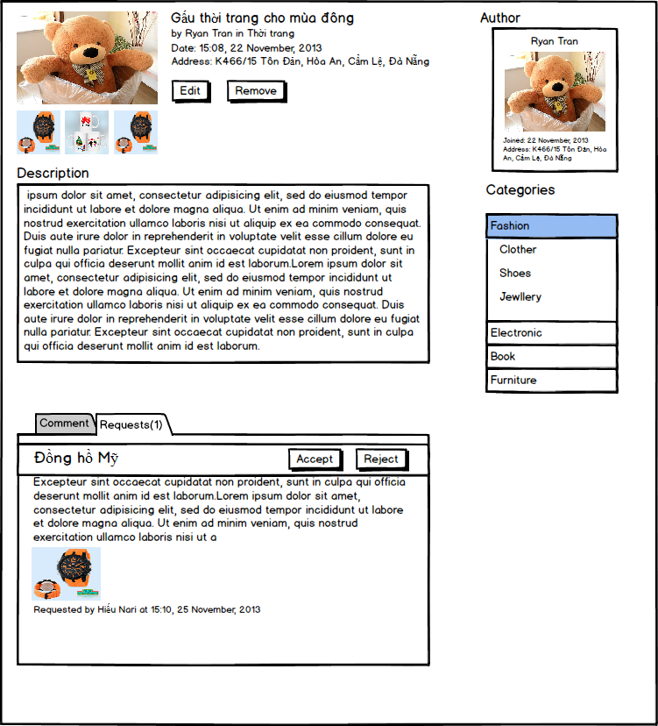
Accept/Reject request interface

Figure 3: Accept/Reject interface

Table 3: Detail description login success interface
Accept/reject Interface |  |  | Code: ID09
No. | Field Name | Type | Target | Comment
1 | Request(1) | Tab selection | Show all request of this topic
2 | “Đồng hồ mỹ..” | Container | Detail information of request
3 | Accept | Button | Accept this request | Request will be change color
4 | Reject | Button | Reject this request

Manage request interface
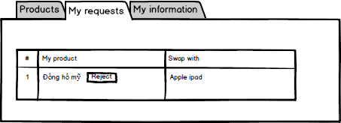
Figure 4: Manage request interface

Table 4: Detail description register interface
Register interface |  |  |  | Code: ID10
No. | Field Name | Type | Null/ Not null | Target | Comment
1 | My requests | Tab selection |  | Text for guide | Color = black Font size = 16
2 | “Đồng hồ mỹ..” | Link |  | Link to edit form of this request | Color = black Font size = 16
3 | Reject | Label |  | Status of this request | Color = black Font size = 16
4 | “Apple ipad…” | Link |  | Link to the item that user want to swap with | Color = black Font size = 16

Appendix A: Approval
Prepared by | Signature | Date
Tran Cong Binh
K16CMU-TTT
Approved by | Signature | Date
Tran Kim Sanh
Mentor
Duy Tan University

Nguyen Trinh Trung Duong
Mentor
Duy Tan University

